* Install Adobe air (choose the correct one for the correct OS)
* Locate to the main directory
* Use Mac, go to Mac directory (use win, go to Win directory)
* Run the “.air” file (accept everything)
* Done

NOTE: If you are using MacOS right now, the apps could be a bit buggy (resolution bug). To solve this, search for the directory of the test emulator (it should be inside of the Application folder). Then, right-click it and choose “show package content”. Then inside the folder, follow this directory structure to get to the final file:  
  
contents/Resources/meta-inf/air

If you are in the air file, you should see the file “application.xml”. Now, delete that “application.xml” and replace it with the same one that comes with the zip file that you just downloaded. After swap the file, restart the app, and it should be fine.

(P/s: inside the file “application.xml”, search for a snippet of code like this: 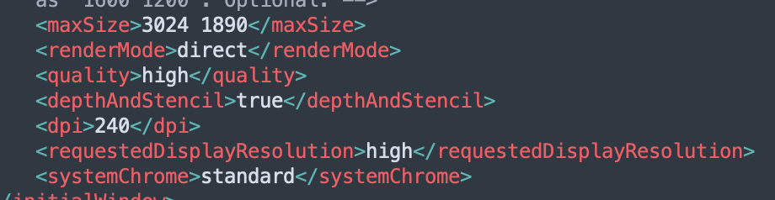

DO NOT CHANGE OTHER CODE !, ONLY CHANGE THE NUMBER BETWEEN THE <maxSize> ONE !

This one will change the initial size of the window of the app when you fire it up, I recommend change it since it depends on which type of computer you use (it can be buggy if you not change it to the best resolution of your computer)